CONTACT:
Zach Baliva
PIO & Director of Communications
Zbaliva@portofh.org
805-616-6881

Port of Hueneme Hosts Regional Dive Teams for Advanced Maritime Search-and-Rescue Training

Four-day ANTX-Coastal Trident exercise unites regional dive teams to train, test emerging technologies, and strengthen mutual-aid response.

PORT HUENEME, CA – Seven regional bomb squad and search-and-rescue dive teams including Ventura County Sheriff’s Office Bomb/Arson Unit and Search & Rescue, Los Angeles Police Department Bomb Squad, Los Angeles Sheriff’s Department Search and Rescue, Santa Barbara Sheriff’s Office Search and Recovery, and Riverside County Sheriff Search and Rescue recently gathered at the Port of Hueneme for an Advanced Naval Technology Exercise (ANTX)-Coastal Trident Event DELTA, a four-day exercise focused on underwater operations and emerging technologies.

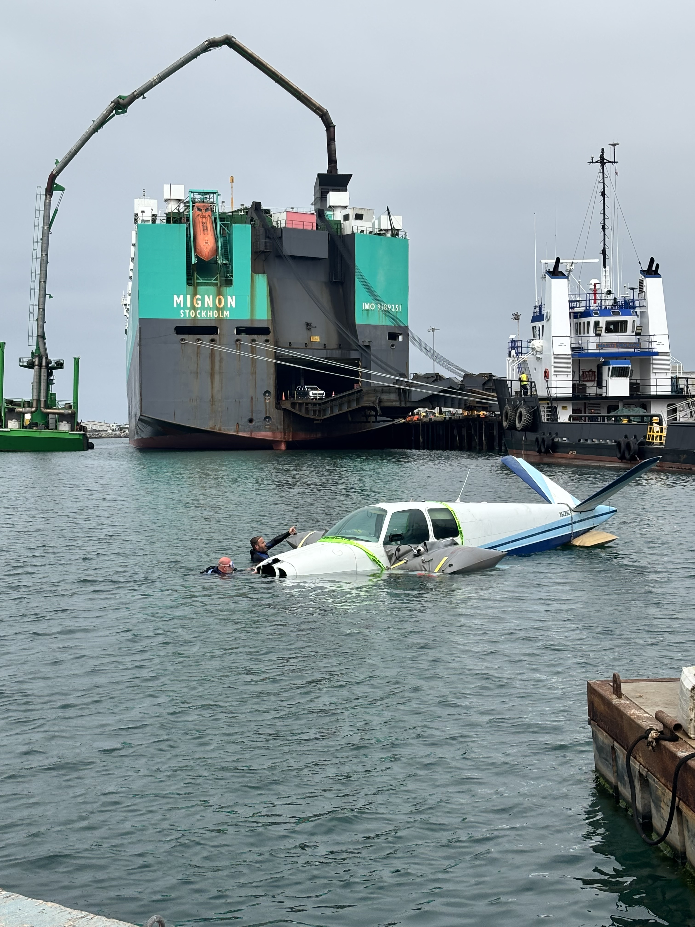
(ANTX)-Coastal Trident Event DELTA

The event featured a vintage A-35 Beech V-Tail Bonanza that was intentionally sunk to give dive teams the opportunity to train in a realistic underwater environment.

Event planners worked closely with the Port’s operations team to schedule the exercise at one of the busiest cargo hubs on the West Coast. The only deepwater seaport between Los Angeles and the San Francisco Bay Area is in the top ten percent of US ports for imports of fresh produce and automobiles. ILWU 46 local longshore workers move $18 billion in cargo annually with activity supporting 25,000 jobs.

“The Port of Hueneme is proud to serve as a training ground where these teams can collaborate and build networks they’ll rely on when unexpected events occur. Having these teams at the Port gives them realistic conditions to train in and that makes our whole community safer,” said Oxnard Harbor District Board President and retired firefighter Jason Hodge.

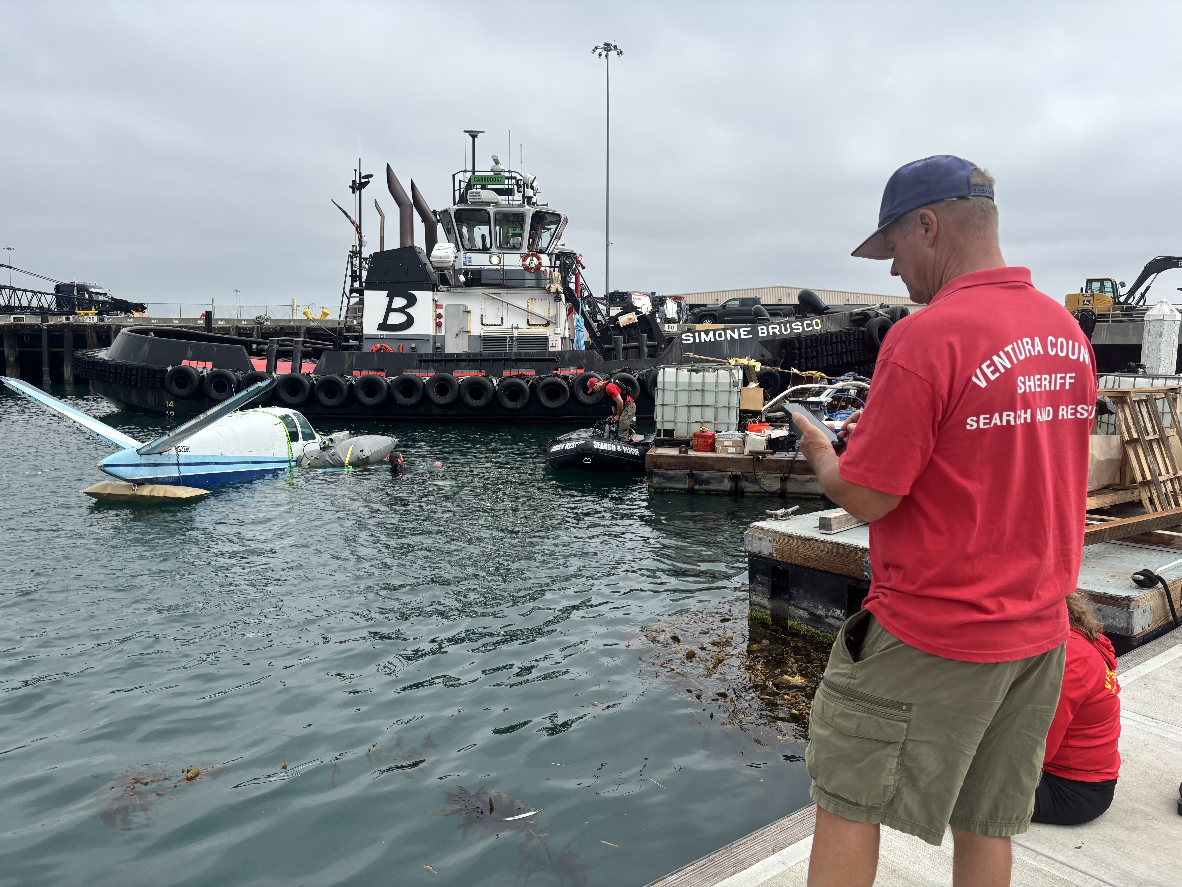
(ANTX)-Coastal Trident Event DELTA

Participants came from various agencies across Southern California for the chance to integrate innovative technologies, including Garmin's S1 Buoy diver tracking and communications system, and to cross-train with teams they'll need to support in mutual-aid incidents. The exercise also facilitated field experimentation with developing underwater domain awareness technologies, including an unmanned surface vessel from Maritime Robotics carrying a Norbit sonar and SIDUS Solutions underwater cameras, a seabed array integrating sensors from Huntington Ingalls Industries, and Hydronet. The underwater exercise allowed divers to provide direct feedback that can influence the ongoing development of systems used in maritime operations.

“Operationally relevant test and experimentation venues like ANTX-Coastal Trident are essential to accelerating technology from concept to capability by putting emerging solutions into the hands of operators in realistic environments. The Port of Hueneme continues to serve as a unique location where technologists from industry, academia, and the operational community can learn together, rapidly iterate, reduce risk, and move the technologies that matter to the fleet forward faster,” said Alan Jaeger, CTO, NSWC PHE.

The exercise further illustrates the Port of Hueneme’s longstanding partnership with the US Navy. The organizations have a joint-use agreement that allows the Port of Hueneme to use Naval facilities that aren’t needed for military operations. Commercial use generates revenue held in escrow and used for infrastructure improvements of shared facilities. The agreement has generated more than $90 million for Naval Base Ventura County.

This ANTX-Coastal Trident event is made possible through the Navy's ongoing collaboration with FATHOMWERX, a technology innovation hub established at the Port of Hueneme in 2018 to connect and accelerate the adoption of promising new technologies. FATHOMWERX brings together partners including Naval Surface Warfare Center Port Hueneme Division (NSWC PHE), Naval Facilities Engineering and Expeditionary Warfare Center (NAVFAC EXWC), Naval Air Warfare Center Weapons Division (NAWCWD), Economic Development Collaborative, Port of Hueneme, and Matter Labs. Together, this partnership gives small businesses and emerging technology developers a unique venue to demonstrate and test their innovations directly with the Navy — helping bridge the gap between promising new technology and real-world naval and maritime security needs.

About the Port of Hueneme: The Port of Hueneme is one of the most productive and efficient commercial trade gateways for niche cargo on the West Coast. Five locally elected Port Commissioners govern the Port. The Port consistently ranks among the top ten U.S. Ports for automobiles and fresh produce. Port operations support the community by bringing $2.8 billion in economic activity and creating 24,997 trade-related jobs. Trade through the Port of Hueneme generates more than $236 million in direct and related state and local taxes, which fund vital community services. In 2017, the Port of Hueneme became the first Port in California to become Green Marine certified and was voted the Greenest Port in the U.S. at the Green Shipping Summit.
About FATHOMWERX
FATHOMWERX is a public-private laboratory, community, and resource for technological innovation that fuses small and non-traditional companies, academic institutions, and other Department of Defense stakeholders together to work on the most challenging problems in the port and maritime domains. FATHOMWERX’s dynamic platform is designed to create a high rate of return for all participants. Through the promotion of divergent thought, neutral facilitation, and the use of a growing ecosystem, the goal of FATHOMWERX is to bring the right minds together to solve challenging problems. The Founding Partners of FATHOMWERX are the Ventura County Economic Development Collaborative, Port of Hueneme, Naval Surface Warfare Center, and Matter Labs.

